# Deep Supermarket: Transfer Learning Approach for Classification of Indian Supermarket Products

**Varun Verma, Dr. Noel Jeygar Robert V**

Vellore Institute of Technology, Chennai

Kelambakkam - Vandalur Rd, Rajan Nagar, Chennai, India

[varun.verma@vitstudent.ac.in](mailto:varun.verma@vitstudent.ac.in), [noeljeygar.robert@vit.ac.in](mailto:noeljeygar.robert@vit.ac.in)

# **ABSTRACT**

The project titled "Deep Supermarket: Transfer Learning Approach to Classify Indian Supermarket Products" intends to conduct a comparative analysis of different deep neural network models in order to effectively categorize Indian supermarket products. This will be achieved by employing both traditional and transfer learning (TL) techniques. The study centres on the necessity of precise product classifier that can identify Indian supermarket / grocery products for retail and self-checkout kiosks, as well as massive automated warehouse storages. The investigation revealed a dearth of image dataset specifically for Indian products, hence necessitating the creation of a customized image dataset (Indian Grocery Image dataset_v3). Initially, Convolutional Neural Network (CNN) and VGG19 models were developed, but their performance was suboptimal. Transfer learning techniques were employed, leveraging pre-trained (weights from ImageNet dataset) models like EfficientNetB7, InceptionResNetV2, DenseNet169, and DenseNet201. The transfer learning models significantly outperformed non-transfer learning models, with the InceptionResNetV2 and DenseNet family of DNN showing exceptional performance. Among the architectures, the DenseNet201 model showed the highest performance, with training accuracy of 99.36% and a validation accuracy of 80.47% making it the most optimal among them for the research problem of classifying Indian supermarket products.

***Keywords:*** *Transfer Learning, CNN, VGG19, EfficientNetB7, InceptionResNetV2, DenseNet169, DenseNet201, Indian Supermarket Products, Custom Dataset*

# **INTRODUCTION**

In the present era of digitalization, the introduction of self-checkouts in supermarkets and the utilization of automated large warehouses for shipping have significantly enhanced the convenience and variety of shopping experiences. The demand for intelligent technologies to categorize products autonomously in retail environments, specifically in automated retail warehouse storage and self-checkout terminals, requires the creation of specialized product classifiers to enhance the purchasing process for customers and warehouse personnel. Extensive research has been conducted on image classification, however, there has been limited investigation into the classification of Indian supermarket/grocery merchandise.

The study titled "Deep Supermarket: Transfer Learning Approach to Classify Indian Supermarket Products" aims to fill this void. This study examines the application of deep neural network models to accurately classify Indian supermarket products using deep learning and transfer learning (TL). The basis of this research is a specialized image dataset consisting of 37,310 images categorized into 15 distinct classes. A custom dataset was required to train and assess models for Indian market applications due to the absence of pre-existing datasets containing images of Indian supermarket/grocery products.

Deep learning models are being evaluated for the purpose of classifying Indian retail products. The initial models consist of a CNN that has been tailored to specific requirements, as well as the VGG19 architecture. Despite implementing architectural changes, hyperparameter tuning, and learning rate tweaks, both models exhibited unsatisfactory performance.

The study subsequently investigates transfer learning by utilizing pre-trained models such as EfficientNetB7, InceptionResNetV2, DenseNet169, and DenseNet201. Transfer learning, the utilization of knowledge gained from one problem to solve another, has revolutionized the field. Classification accuracy was higher in transfer learning models compared to non-transfer learning models when utilizing ImageNet weights.

The EfficientNetB7 model was projected to exhibit superior performance, albeit only marginally surpassing the CNN and VGG19 models. On the other hand, the InceptionResNetV2 and DenseNet models, including DenseNet169 and DenseNet201, exhibited strong performance but also demonstrated signs of overfitting. The study will assess different model architectures, analyse their performance through empirical and graphical methods, and suggest the most suitable models for the Indian supermarket items dataset.

Thus the two primary challenges addressed by this research are creating a custom image dataset and developing robust deep learning models for Indian supermarket product classification. This study uses transfer learning and a custom image dataset to fill the literature gap and offer insights into categorizing Indian retail goods. Empirical evaluation and analysis will determine the best deep learning architectures for Indian supermarket product classification accuracy, which will improve retail operations and customer experiences in the Indian automated supermarkets.

# **RELATED WORKS**

• *"Store product classification using CNN" by I Made Wiryana, Suryadi Harmanto, Alfharizky Fauzi, Imam Bil Qisthi, Zalita Nadya Utami* - The paper explores the application of Convolutional Neural Network (CNN) architectures to enhance the efficiency and cost-effectiveness of store product sorting. It delves into the realm of deep learning-based retail product recognition, emphasizing the pivotal role of CNN models in object detection. Through a thorough literature review, the paper elucidates the challenges, methodologies, and datasets pertinent to deep learning-based product recognition, offering valuable insights for researchers and practitioners venturing into this domain. The evolution of retail product recognition from traditional computer vision to deep learning is meticulously discussed

• *Muhathir et al.'s "Convolutional Neural Network (CNN) of Resnet-50 with Inceptionv3 Architecture in X-Ray Image Classification"* - Advanced CNN architectures Resnet-50 and Inceptionv3 are used to classify X-ray images. The computationally efficient Inceptionv3 uses factorized convolutions, smaller convolutions, asymmetric convolutions, auxiliary classifiers, and grid size reduction to improve network performance and reduce computational costs. When combined with auxiliary classifiers, convolution factorization, RMSProp optimization, and Label Smoothing, Inceptionv3, from Christian Szegedy et al.'s 2015 paper "Rethinking the Inception Architecture for Computer Vision", outperforms other models on ImageNet with lower error rates. The synergy of Resnet-50 and Inceptionv3 architectures shows how architectural refinements improve model efficiency and performance for X-ray image classification.

• *“An effective CNN and Transformer complementary network for medical image segmentation”, ScienceDirect* - The paper examines how CNN and Transformer encoders can improve medical image segmentation. CNN encoders represent local features well, but Transformer encoders model long-range dependencies, requiring their integration. The proposed ConvFormer architecture learns local and global representations using CNN and Transformer components to improve medical image segmentation. ConvFormer outperforms CNN- and Transformer-based medical image segmentation models using a feed-forward module called Enhanced DeTrans for local information integration, a residual-shaped hybrid stem for capturing local and global features, and an encoder for multi-scale feature maps. CNN and Transformer architectures improve medical image analysis accuracy and efficiency in this novel approach.

• *"Comparison of CNN-based deep learning architectures for rice disease classification," ScienceDirect* – The paper evaluates various CNN architectures in the context of rice disease classification using deep learning techniques. The study investigates the performance of GoogleNet, ResNet-18, SqueezeNet-1.0, and DenseNet-121 for detecting rice diseases. Highlighting the challenges in CNN-based rice disease recognition and proposing avenues for future research, the paper underscores the significance of deep learning models in automating image feature extraction for rice disease classification. By offering a comprehensive comparison of CNN architectures, the study provides valuable insights for agricultural researchers and practitioners seeking optimal deep learning models for rice disease classification.

• *"Deep Learning Model Based on ResNet-50 for Beef Quality Classification"* S. E. Abdallah, W. M. Elmessery, M. Shams, N. SA Al-Sattary - The study uses surface texture analysis to distinguish healthy and rancid beef images. Only eight healthy and ten rancid beef images were available, so a Generative Adversarial Network (GAN) was used to add 180 more images. ResNet-50-based classification model achieved 96.03% training, 91.67% testing, and 88.89% validation accuracy, proving deep learning's beef quality classification efficacy. ResNet-50's image classification efficiency was further demonstrated by comparison with classical and other deep learning architectures. A robust ResNet-50-based deep learning model that accurately categorizes beef images, overcomes data limitations, and improves classification accuracy through advanced deep learning methodologies contributes to food quality assessment.

• *“Performance evaluation of ResNet model for tomato plant disease classification” by S. Kumar, Pal, Singh, and P. Jaiswal -* The study evaluates the ResNet model's tomato disease classification capabilities. The study tests ResNet's ability to detect tomato diseases like early and late blight, leaf mold, leaf spot, two-spotted spider mite, target spot, yellow leaf curl virus, and mosaic virus. The study compares Inception V3 and Inception ResNet V2 models using PlantVillage and other platform images of diseased and healthy tomato leaves. ResNet excels in training, testing, and validation, proving its tomato plant disease classification efficacy. This study advances plant disease classification methods and helps agricultural researchers and practitioners find the best deep learning models for tomato disease classification.

• *“An Enhanced Transfer Learning Based Classification for Skin Cancer Diagnosis” by V. Anand et al. K. Jilani Saudagar* - A transfer learning-based deep learning model for benign and malignant skin cancer diagnosis is investigated. K. Jilani Saudagar improved skin cancer classification by layering and fine-tuning the VGG16 model. The proposed framework optimises classification by integrating input dataset preparation, data augmentation, VGG16 feature extraction, and model fine-tuning. Experimental results show that the enhanced transfer learning approach classifies skin cancer with high training, testing, and validation accuracy. Comparing the proposed model to existing diagnostic methods confirms its superiority. This research improves automated skin cancer diagnosis systems and helps medical researchers and practitioners improve diagnostic tools.

• *“A Study of CNN and Transfer Learning in Medical Imaging: Benefits, Challenges, and Future Prospects” by A. Salehi et al –* In the study, CNNs and transfer learning are thoroughly reviewed. They emphasize how these methods improved medical image analysis accuracy, resource use, and efficiency. The paper addresses limited training data, overfitting, and transfer learning method selection. CNN components and deep learning algorithm hardware platforms are explained in detail. The study reviews current research and explores advanced CNN architectures to help medical imaging researchers and students use CNNs and transfer learning for better diagnostics and healthcare efficiency.

• *M. created a hybrid CNN-LSTM-based transfer learning method to classify benign and malignant breast cancer subtypes in BMC Medical Imaging. V. P. Subramanyam Rallabandi, D. B. Dudekula, S. Natarajan, and J. Park -* The study aims to develop a deep learning model to classify breast cancer histopathology images as benign or malignant and predict four cancer subtypes. Their hybrid CNN-LSTM model uses transfer learning, trained on ImageNet and fine-tuned on BreakHis, which contains benign and malignant cancer images at various magnifications. The hybrid CNN-LSTM model outperforms ResNet50 and Inception in binary and multi-class classification tasks after extensive evaluation with different optimizers and epochs. The proposed model may improve breast cancer clinical diagnostic accuracy and efficiency.

• *“Fusion of U-Net and CNN model for segmentation and classification of skin lesions from dermoscopy images” – ScienceDirect -* addresses fuzzy borders and irregular boundaries by developing a hybrid model. U-Net segmentation accuracy is improved by modifying feature map dimensions and increasing kernels for precise nodule extraction. The model performs best with an Adam optimizer, 8 batches, and 75 epochs after experimenting with hyperparameters like epochs, batch size, and optimizers. A modified U-Net architecture for dermoscopy skin lesion segmentation may improve dermatology diagnosis by improving segmentation and classification.

• *“Product Classification in E-Commerce Sites,” A. Vivek Patra, B. R. Shambhavi, K. Sindhu, S. Balaji* - Product categorization improves online shopping platform user experience and conversions, according to the study. Effective catalogue classification improves customer experience, sales, and website searchability, improving shopping experiences. Precision navigation and data classification speed up transactions, increasing e-commerce sales. Structured product pages also help analyze sales performance and make informed decisions, improving operational efficiency and customer engagement. The study emphasizes the importance of product classification in e-commerce customer engagement, operational efficiency, and sales conversions.

• *“A Machine Learning-Based Autonomous Framework for Product Classification Over Cloud,”* by A. Motwani, G. Bajaj, M. Arya, S. K. Sar, S. O. Manoj - The paper introduces a cloud-based machine learning framework for e-commerce product classification. The study uses multiclass logistic regression in a cloud computing infrastructure to improve efficiency, accuracy, and scalability for large product volumes. The framework aims to simplify and improve e-commerce user experience by developing an autonomous system that can categorize products without expert knowledge. Machine learning algorithms and cloud resources improve scalability, efficiency, and accuracy for dynamic e-commerce platforms with diverse product inventories. This study shows how machine learning and cloud infrastructure can automate product classification, improving user experience, operational efficiency, and decision-making in e-commerce.

• *“CNN-Based Crop Disease Identification Using ResNet-50” - IEEE Conference Publication, IEEE Xplore -* Microdrones, CGQ, Mitacs, and MEI funded the study to automatically detect crop diseases from images using deep learning, particularly CNNs. The paper evaluates 19 CNN-based crop disease identification studies' profiles, implementations, and results. It finds issues like nonconformity that could hinder models' generalization across data samples and imaging conditions. The authors suggest CNN improvements for operational use and future research, emphasizing deep learning's potential to revolutionize crop disease identification and improve food production security and sustainability.

• *Kılıçarslan et al. performed breast lesion classification using features fusion and ensemble ResNet method -* A breast lesion classification study using ensemble ResNet and the ALL-ResNet NCA model achieved 84.9% accuracy. MR-MR, NCA, and Relieff perform well in experiments. The study emphasizes accurate breast cancer diagnosis and monitoring despite technological advances. The research evaluates machine learning algorithms and uses ensemble classification to improve classification accuracy. The majority-based voting mechanism outperforms existing algorithms in breast lesion classification accuracy. The study classifies breast lesions as normal, malignant, or benign using ensemble methods and ResNet models.

• *"Fabric defect detection and classification using modified VGG network" R. S. Sabeenian, Eldho Paul, C. Prakash* - The paper introduces a deep learning framework for AI-based fabric type and defect classification. The study improves fabric defect detection and classification using a modified VGG network to address five defects. The research shows that deep learning can improve textile manufacturing quality control, led by authors R. S. Sabeenian, Eldho Paul, and C. Prakash and Christ University Assistant Professor Eldho Paul. The modified VGG network accurately detects and classifies fabric defects, demonstrating deep learning's benefits in textile quality assurance.

# **METHODOLOGY**

Our research commenced with the establishment of dataset_v2, serving as a foundational element for subsequent inquiries. Initial efforts involved constructing traditional models, namely custom CNN and VGG19 architectures, employing various training methodologies. However, despite optimization attempts, their efficacy was compromised when trained on the imbalanced dataset_v2. This highlighted the critical need for balanced data in our study. Subsequently, dataset_v3 was introduced, tailored to rectify previous issues, prompting a revaluation of the conventional models' training. Although some marginal enhancements were observed, the outcomes remained suboptimal, indicating mediocre performance.

Transitioning to Transfer Learning, we initially implemented the EfficientNetB7 model using dataset_v2. Initially, both iterations of the Transfer Learning model yielded unsatisfactory results, echoing the challenges encountered with traditional models. However, with the adoption of dataset_v3, notable improvements in model performance were witnessed, underscoring the pivotal role of balanced data in enhancing classification outcomes.

Further exploration led us to focus on robust Transfer Learning models such as InceptionResNetV2, DenseNet169, and DenseNet201. These models exhibited promising classification capabilities, adeptly handling the image classification tasks inherent in our research. Despite their initial success, overfitting emerged as a significant concern, as evidenced by notable disparities between training and testing scores. To address this issue, additional refinements were implemented, ultimately bolstering the models' performance.

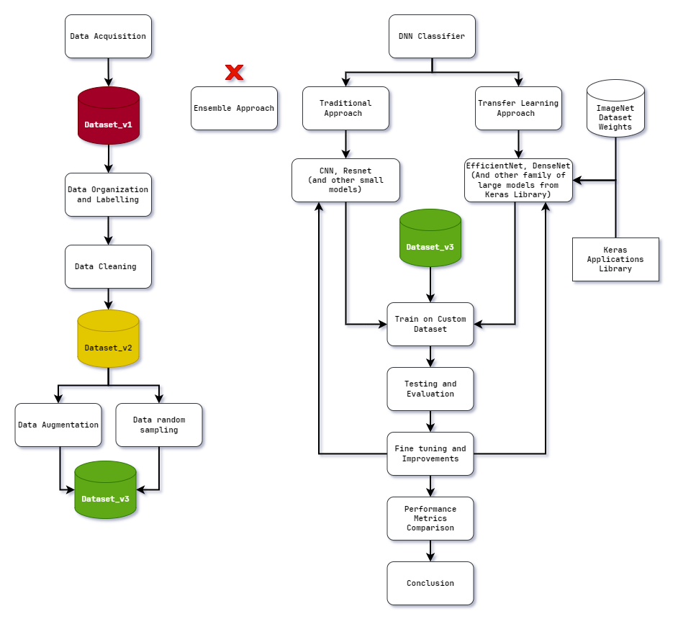

**Figure 1 : Methodology of study**

## **DATASET CREATION**

*Data Acquisition:* At the onset, images were gathered from online search engines to collect a wide range of visual data.

*Dataset_v1:* The creation of dataset_v1 signified the compilation of raw images obtained directly from search engine results. The dataset's original structure, which included nested folders within class directories, needed to be adjusted to meet classification needs.

*Data Organization and Labelling:* After organizing and labelling the data, the images were sorted into their appropriate class folders to ensure correct labelling and improve the hierarchical structure for better classification preparation.

*Data Cleaning:* During this crucial stage, redundant and irrelevant images were carefully removed from the dataset to maintain data integrity and reduce the risk of contamination.

*Dataset_v2:* After completing the steps mentioned above, dataset_v2 was obtained. It is a refined version of the dataset, free of unusable images but facing a notable class imbalance issue.

*Data Augmentation:* Efforts were made to tackle class imbalance by utilizing data augmentation techniques to increase the number of samples for classes with limited images, aiming to create a more balanced dataset.

*Random Sampling:* On the other hand, classes that had too many images used random sampling to reduce the number of images in order to create a more balanced distribution among classes.

*Dataset_v3:* Through the combination of data augmentation and random sampling, dataset_v3 has been developed to improve model training by providing a more comprehensive and fair approach.

## **MODEL CREATION AND COMPARISION**

*DNN classifier:* The model creation methodology focused on designing an optimal Deep Neural Network (DNN) classifier for Indian supermarket products. An extensive literature review identified Ensemble, Traditional, and Transfer Learning as the main DNN classifier development methods.

*Traditional Approach:* Ensemble methods, despite their strong theoretical foundation, were considered unfeasible due to their complexity and required knowledge. Smaller traditional architectures - CNN and VGG models were constructed layer by layer. These models were easy to create and implement, but their effectiveness in addressing study challenges like low-quality data, limited image quantities, class imbalances, and dataset cleanliness was unclear. Despite these drawbacks, the conventional CNN and VGG DNN models are also built to evaluate against the TL model performances.

*Transfer Learning Approach:* Transfer Learning (TL) is a promising approach that fits the research problem well. Using pre-trained weights from the ImageNet dataset, TL models’ architecture could be imported from the Keras Application library to speed up model development and improve performance. Since TL models were chosen as the foundation for model creation, EfficientNet, DenseNet, and InceptionResNet model architectures were used.

*Train, Test, Evaluation on Custom Dataset:* The selected models were trained on dataset_v3 and evaluated based on their performance metrics in testing and training. This assessment was used to fine-tune and optimize the model's performance through hyperparameter adjustments and other methods.

*Performance Comparison and Conclusion:* the study would then evaluate model performance using testing and training scores and visual representations. The conclusions addressed the research problem and provided insights into the best model for classifying Indian supermarket products.

# **RESULTS AND INFERENCES**

This research shed light on the efficacy of various models for the classification of Indian supermarket products. Through a meticulous methodology encompassing dataset creation, model construction, and performance evaluation, the study gained valuable insights into the strengths and limitations of different approaches.

The traditional model approach, where custom CNN and VGG19 architectures were developed, encountered significant challenges stemming from class imbalances within the dataset. Despite efforts to address these imbalances and fine-tune model parameters, the performance of traditional models remained suboptimal, indicating their limited suitability for the classification task for the study.

Firstly, the results of this research include the creation of a new unique dataset - "Indian Grocery Image dataset_v3" with over 37K images, which contained categorized, labelled images of Indian supermarket / grocery products.

Secondly The study clearly demonstrate that the performance of the different models varied greatly depending on the architectures used. The accuracy and loss measures were employed to assess the efficacy of each model in categorizing Indian supermarket goods using the given dataset.

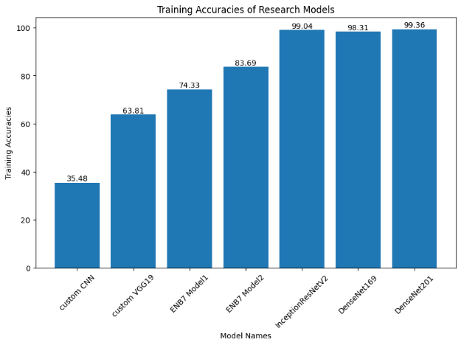

**Figure 2: Training Accuracies of Models**

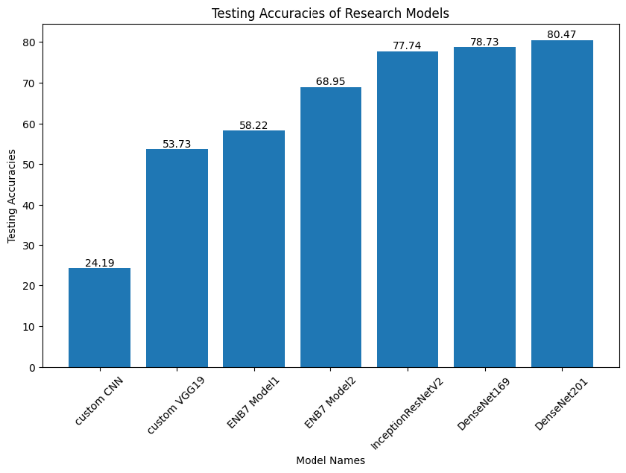

**Figure 3 : Testing Accuracies of Models**

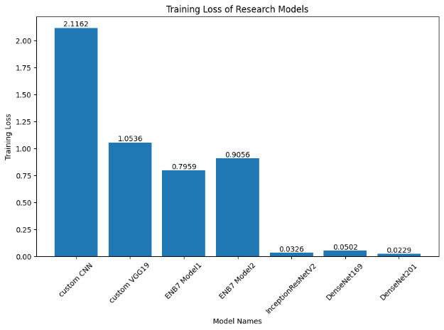

**Figure 4 : Training Loss of Models**

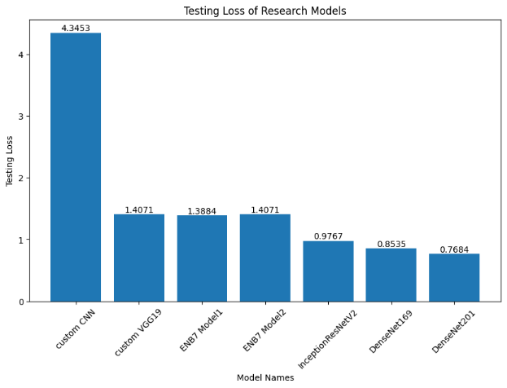

**Figure 5 : Testing Loss of Models**

**Table 1 : Comparisons of Training and Testing Scores of Models**

|  |  |  |  |  |
| --- | --- | --- | --- | --- |
| **MODEL NAME** | **TRAINING ACCURACY (%)** | **TESTING ACCURACY (%)** | **TRAINING LOSS** | **TESTING LOSS** |
| **Custom CNN** | 35.48 | 24.19 | 2.1162 | 4.3453 |
| **VGG19** | 63.80 | 53.73 | 1.0536 | 1.4071 |
| **ENB7 Model1** | 74.33 | 58.22 | 0.7959 | 1.3884 |
| **ENB7 Model2** | 83.69 | 68.95 | 0.9056 | 1.4071 |
| **InceptionResNetV2** | 99.04 | 77.74 | 0.0326 | 0.9767 |
| **DenseNet169** | 98.31 | 78.73 | 0.0502 | 0.8535 |
| **DenseNet201** | 99.36 | 80.47 | 0.0229 | 0.7684 |

# **CONCLUSION**

The traditional CNN and VGG19 models, although they are the easiest to deploy, exhibited somewhat inferior performance in comparison to the more intricate models. The training and testing accuracies for these models were comparatively low, suggesting a challenge in generalizing to unfamiliar data. The elevated testing loss values provide more evidence of the subpar performance of these models.

In contrast, the EfficientNetB7 (ENB7) models demonstrated superior performance in comparison to the traditional architectures. Both Model1 and Model2 of ENB7 exhibited superior training and testing accuracies, with Model2 surpassing Model1 in both metrics. The ENB7 models have reduced testing loss values, indicating superior generalization potential in comparison to all the other models.

Finally, the InceptionResNetV2, DenseNet169, and DenseNet201 models exhibited the utmost accuracy compared to all other designs. These models demonstrated exceptional performance in terms of both training and testing accuracies, with minimal overfitting reported. The models' low testing loss values suggest that they may effectively generalize to new data, making them highly suitable for the classification task of the research. Among these architectures, the **DenseNet201 model** showed the highest performance compared to any other model that was implemented, making it the most optimal among them to address the problem of classifying Indian supermarket products.

## **FUTURE WORKS**

There are several avenues for further exploration and improvement based on the study's findings. Firstly, there's a need to delve deeper into data augmentation techniques and dataset balancing strategies to enhance model performance, particularly for traditional architectures.

Additionally, exploring a wider range of architectural designs beyond those studied, possibly from platforms like TensorFlow Hub and Model Zoo, could lead to the discovery of more optimal models.

Extensive hyperparameter tuning trials and exploration of ensemble learning techniques are also suggested to further optimize performance.

Investigating alternative transfer learning techniques and designing domain-specific architectures tailored to Indian supermarket product images is also another way to improve upon the study.

# **ACKNOWLEDGEMENT**

I gratefully acknowledge the invaluable guidance and support extended to me by Dr. Noel Jeygar Robert V, Assistant Professor Sr Grade 1, School of Computer Science and Engineering, Vellore Institute of Technology, Chennai. His constant encouragement, guidance, and expertise in the field of Artificial Intelligence (AI) and Networks have been instrumental in shaping my research journey.

I also extend my heartfelt appreciation to the esteemed leadership at Vellore Institute of Technology, including Dr. G. Viswanathan, our Honorable Chancellor, Mr. Sankar Viswanathan, Dr. Sekar Viswanathan, Dr. G V Selvam Vice Presidents, Dr. Sandhya Pentareddy, Executive Director, Ms. Kadhambari S. Viswanathan, Assistant Vice-President, Dr. V. S. Kanchana Bhaaskaran Vice-Chancellor i/c & Pro-Vice Chancellor, VIT Chennai, and Dr. P. K. Manoharan, Additional Registrar, for fostering an exceptional learning environment.

Special gratitude is also extended to Dr. Ganesan R, Dean, Dr. Parvathi R, Associate Dean Academics, Dr. Geetha S, Associate Dean Research, School of Computer Science and Engineering, Vellore Institute of Technology, Chennai, for their valuable time, guidance, and knowledge sharing throughout the course.

I extend my sincere thanks to Dr. Nithyanandam P, Head of the Department, B.Tech. CSE, and the Project Coordinators for their unwavering support and encouragement throughout the thesis completion process.

My gratitude extends to all the faculty and staff at Vellore Institute of Technology, Chennai, for their contributions to my academic journey. Lastly, I am deeply grateful to my parents for their unwavering support, and to my best friend Somya Kumari, whose encouragement has been invaluable in completing this endeavour.

# **REFERENCES**

[0] Base Paper : Wiryana, Made & Harmanto, Suryadi & Fauzi, Alfharizky & Qisthi, Imam & Utami, Zalita. (2023). Store product classification using convolutional neural network. IAES International Journal of Artificial Intelligence (IJ-AI).12.1439.10.11591/ijai.v12.i3.pp1439-1447.Available: https://ijai.iaescore.com/index.php/IJAI/article/view/22455

[1] Muhathir, M. F. Dwi Ryandra, R. B. Y. Syah, N. Khairina, and R. Muliono, “Convolutional Neural Network (CNN) of Resnet-50 with Inceptionv3 Architecture in Classification on X-Ray Image,” Convolutional Neural Network (CNN) of Resnet-50 with Inceptionv3 Architecture in Classification on X-Ray Image | SpringerLink, Jul. 09, 2023. [Online]. Available: https://link.springer.com/chapter/10.1007/978-3-031-35314-7_20

[2] “An effective CNN and Transformer complementary network for medical image segmentation,” An effective CNN and Transformer complementary network for medical image segmentation - ScienceDirect, Nov. 30, 2022. [Online]. Available: https://www.sciencedirect.com/science/article/abs/pii/S0031320322007075

[3] “Comparison of CNN-based deep learning architectures for rice diseases classification,” Comparison of CNN-based deep learning architectures for rice diseases classification - ScienceDirect, Jul. 14, 2023. [Online]. Available: https://www.sciencedirect.com/science/article/pii/S2589721723000235

[4] S. E. Abdallah, W. M. Elmessery, M. Y. Shams, and N. S. A. Al-Sattary, “Deep Learning Model Based on ResNet-50 for Beef Quality Classification,” Arab Journals Platform, Oct. 08, 2022. [Online]. Available: https://digitalcommons.aaru.edu.jo/isl/vol12/iss1/24

[5] S. Kumar, S. Pal, V. P. Singh, and P. Jaiswal, “Performance evaluation of ResNet model for classification of tomato plant disease,” De Gruyter, Jan. 01, 2023. [Online]. Available: https://www.degruyter.com/document/doi/10.1515/em-2021-0044/html

[6] V. Anand, S. Gupta, A. Altameem, S. R. Nayak, R. C. Poonia, and A. K. Jilani Saudagar, “An Enhanced Transfer Learning Based Classification for Diagnosis of Skin Cancer,” MDPI, Jul. 05, 2022. [Online]. Available: https://www.mdpi.com/2075-4418/12/7/1628

[7] A. W. Salehi et al., “A Study of CNN and Transfer Learning in Medical Imaging: Advantages, Challenges, Future Scope,” MDPI, Mar. 29, 2023. [Online]. Available: https://www.mdpi.com/2071-1050/15/7/5930

[8] M. M. Srikantamurthy, V. P. Subramanyam Rallabandi, D. B. Dudekula, S. Natarajan, and J. Park, “Classification of benign and malignant subtypes of breast cancer histopathology imaging using hybrid CNN-LSTM based transfer learning - BMC Medical Imaging,” SpringerLink, Jan. 30, 2023. [Online]. Available: https://link.springer.com/article/10.1186/s12880-023-00964-0

[9] “Fusion of U-Net and CNN model for segmentation and classification of skin lesion from dermoscopy images,” Fusion of U-Net and CNN model for segmentation and classification of skin lesion from dermoscopy images - ScienceDirect, Nov. 09, 2022. [Online]. Available: https://www.sciencedirect.com/science/article/abs/pii/S0957417422022485

[10] A. Patra, V. Vivek, B. R. Shambhavi, K. Sindhu, and S. Balaji, “Product Classification in E-Commerce Sites,” Product Classification in E-Commerce Sites | SpringerLink, Apr. 16, 2021. [Online]. Available: https://link.springer.com/chapter/10.1007/978-981-33-4299-6_40

[11] A. Motwani, G. Bajaj, M. Arya, S. K. Sar, and S. O. Manoj, “Machine Learning-Based Autonomous Framework for Product Classification Over Cloud,” Machine Learning-Based Autonomous Framework for Product Classification Over Cloud | SpringerLink, May 31, 2023. [Online]. Available: https://link.springer.com/chapter/10.1007/978-981-19-9638-2_6

[12] M. I. Basheer Ahmed et al., “Deep Learning Approach to Recyclable Products Classification: Towards Sustainable Waste Management,” MDPI, Jul. 17, 2023. [Online]. Available: https://www.mdpi.com/2071-1050/15/14/11138

[13] “Convolutional Neural Network (CNN) Based Identification of Crop Diseases Using ResNet-50,” Convolutional Neural Network (CNN) Based Identification of Crop Diseases Using ResNet-50 | IEEE Conference Publication | IEEE Xplore. [Online]. Available: https://ieeexplore.ieee.org/abstract/document/10370122

[14] Kılıçarslan G, Koç C, Özyurt F, Gül Y. Breast lesion classification using features fusion and selection of ensemble ResNet method. Int J Imaging Syst Technol. 2023; 33(5): 1779-1795. doi:10.1002/ima.22894

[15] R. S. Sabeenian, Eldho Paul & C. Prakash (2023) Fabric defect detection and classification using modified VGG network, The Journal of The Textile Institute, 114:7, 1032-1040, DOI: 10.1080/00405000.2022.2105112